|  |  |  |  |
| --- | --- | --- | --- |
| **Changes control** | | | |
| Version | Date | Author | Details of changes |
| 1 | 2015-02-24 | Claudia Velarde | Create the document |
|  |  |  |  |
|  |  |  |  |

|  |  |  |  |  |
| --- | --- | --- | --- | --- |
|  | Name | Position | Approval date | Signature |
| Made by: |  |  |  |  |
| Reviewed by: |  |  |  |  |
| Approved by: |  |  |  |  |

# GENERAL CONFIGURATION

Depending if the environment is for development or production, the configuration of the following fields with their corresponding values needs to be completed.

***View:*** CF UI menu bar 🡪 Configure 🡪 WSI

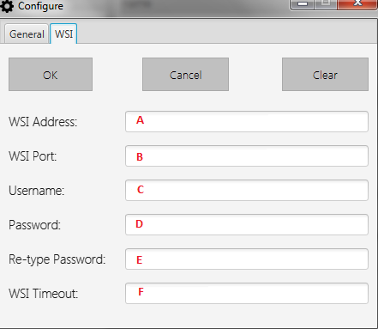

**A:** IP address of the WSI.

**B:** Port of the WSI.

**C:** Username to access to the WSI.

**D:** Password that belongs to the introduced username.

**E:** Re-type the previous typed password.

**F:** Timeout for connection to the WSI in seconds.